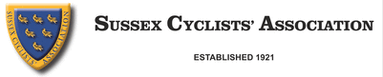
Annual General Meeting 2021
MEETING HELD AT DIAL POST VILLAGE HALL ON NOVEMBER 24th
Members present:
Robin Johnson, Paul Thatcher, Steve Dennis, Peter Moon, David Shepherd, Clive Jackson.
Members absent:
David Collard Berry, Brett Davis, Lisa Davis, Chris Parker, Chris Woods, Bob Harber.
Meeting started at 8.20pm.
Minutes of last meeting agreed.
Secretary's report: Proposed by Paul Thatcher, seconded by Steve Dennis.
Report attached.
Treasurer's report: Proposed by Peter Moon, seconded by David Shepherd.
Report attached.
Time Trial report:
Proposed by David Shepherd, seconded by Paul Thatcher.
Report attached.
Competition secretary's report:
No report, all results on website.
Webmasters report: Nothing to report.
Election of Officers:
President Robin Johnson
Chairman Robin Johnson
General Secretary David Shepherd
Treasurer Paul Thatcher
Time Trial Secretary Steve Dennis
Competition Secretary Brett Davis
Webmaster Position vacant
Auditor Katerina Pemberton
All proposed by Clive Jackson, seconded by Paul Thatcher.
Approval of race dates 2022: Proposed by Paul Thatcher, seconded by David Shepherd.
Future of Lunch and Prize presentation:
For 2022 a coffee morning and prize presentation will be held at Dial Post village hall on Sunday 20th February between 10am and 2.30pm.
Meeting closed at 9.50pm.

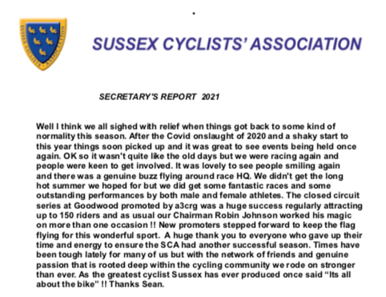

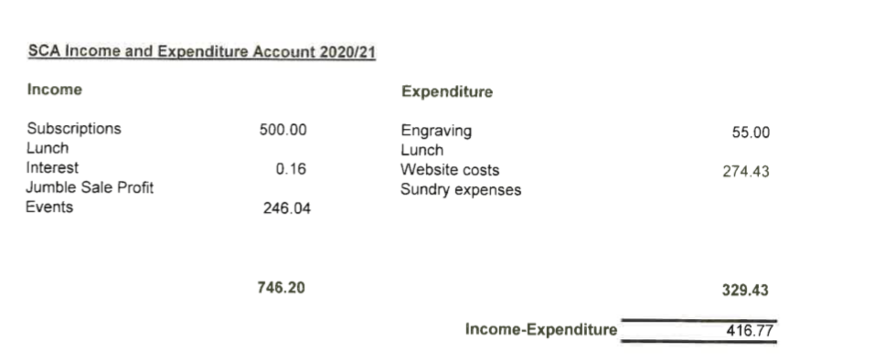
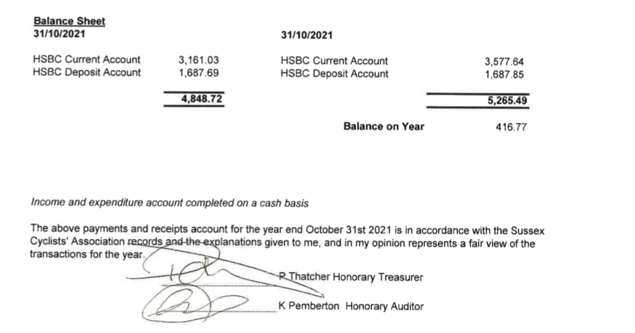

TT Report For 2021 SCA AGM
After a delayed start due to the COVID situation, things eventually got going on the 1st May with the Championship 10. There now follows a brief recap of the seasons events for which full details are available on the Association’s website, including all start and result sheets for each event.
- Championship 10 - 1st May. 89 riders. Winner and SCA Champion – Mark Smith (Crawley Wheelers) 20:15. Fastest woman (and SCA Women’s Champion) Sally Turner (trainSharp) 22:30.
This was to be Jon Fry’s last promotion of the 10, to which we owe grateful thanks for all his hard work over the past years. Stuart Betis of HuntBikeWheels.com has kindly offered to promote in 2022.
- Championship 25 – 2nd May. 87 solos, 1 tandem. Winner and fastest Junior: Mattie Dodd (Team Backstedt Bike Performance) 51:53. SCA Champion: Mark Smith 52:20. Fastest Woman and SCA Woman’s Champion: Sally Turner 58:24.
- Team Time Trial – rescheduled to 23rd May. 13 road bike teams and 13 tt bike teams. Winners: Mark Smith/Kevin Nelson (Crawley Wheelers) 1:00:10 (tt bikes); Paul Burton/Michael Cunliffe (Paceline RT) 1:01:05 (road bikes).
- Championship 15 – 12th June. 57 solos, 1 tandem. Winner and SCA Champion Steve Kane (Team TMC) 31:00. Fastest Woman Bethan Male (Brighton Triathlon Club) 37:47. Women’s SCA Champion: Tracey Williams (Brighton Excelsior CC) 40:02. Tandem: Mark Jones/Tony Reeves (GS Stella) 32:54 for a new tandem record and new Team record from Team TMC with 1:34:37 (Kane; Smith; Nik Allen).
- Championship 50 – 27th June. 73 riders – the best entry since before 1998. Winner and SCA champion: Steve Kane (Team TMC) 1:49:57. Fastest Woman: Lisa Davis (DRAG2ZERO) 2:08:19, SCA Women’s Champion: Anouska Greenaway (Brighton Mitre CC) 2:15:34. New Team Event Record of 5:37:05 (Team TMC – Steve Kane; Matt Smith; Kevin Plummer)
- Championship 100 miles (in conjunction with the SCCU 100) on 18th July. Overall winner and SCA Champion: Steve Kane (Team TMC) 3:44:48. SCA Women’s Champion: Anouska Greenaway 4:39:24.
- (The not quite) Centenary 10 – 24th July. 55 riders on the start list but only 34 started. The winner was Jack Allison of GS Henley in 21:55. The best SCA rider was Mark Smith of Crawley Wheelers in 22:08. Fastest Woman was Jennifer George (The Independent Pedaler/Nopinz) 22:59. (The Centenary event will be in 2025)
- Championship 30 – 25th July. 35 riders entered. Winner and SCA Champion: Matthew Smith (Team TMC) 1:03:07. SCA Women’s Champion: Anouska Greenaway (Brighton Mitre CC) 1:18:39. New SCA Team record for 30 miles: 3:14:00 (Team TMC - Matt Smith; Steve Kane; Martin Gibbs).

- Sporting 10 & 25 weekend – 28th & 30th August. The 10 had 56 riders over 3 different categories, the fastest on the day being Simon McNamara of HuntBikeWheels.com in the tt bike category with 21:41. Monday’s 25 had 44 riders over 3 categories with the fastest time being a tie between Simon McNamara and Matt Smith (Team TMC) with 54:46. Fastest Woman was Tracey Williams (Brighton Excelsior CC) in 1:13 21.
- Hill Climb Championship – 2nd October. Andy Tedd’s first promotion of the Hill Climb proved popular with 71 riders on the start list. Bad weather resulted in a lot of non-starters but it didn’t put off the winner Gabe Dellar of Southampton University who stormed up the Steyning Bostal climb in 4:14.58. Best placed SCA rider and SCA Champion was Richard Cartland (HuntBikeWheels.com) who rode for a very close 4th place with 4:19.71. Fastest Woman was Miriam Jessett (Vredestein Basso) with 5:21.77. Best SCA Woman was Kate Parrish (Lewes Wanderers CC) 5:40.84.
- Hardriders – rescheduled to 17th October. 35 entries including the road bikes’ event measured up for this challenging course and was won in style by seasoned veteran Colin McDermott (Festival RC) who claimed a couple of notable scalps along the way. His time of 1:00:29 was just 2 seconds quicker than 2nd placed Pat Wright (Paceline) and 34 seconds better than Team TMC’s Steven Kane.

- Event dates for 2022:
6th March Hard Riders (to include Road Bikes event) GS/194
1st May Team TT (to include Road Bike event) GS/987
7th May 10 Championship G10/97
8th May 25 Championship G25/93
11th June 15 Championship G15/93
26th June 50 Championship G50/10
24th July 30 Championship G30/91
27th August Sporting 10 (4 events) G10/45
29th August Sporting 25 (3 events) G25/49
1st October Hill Climb GH/92

